5 Indoor Alternatives for Exercising with Your Dog
By: Amber Kingsley

Sometimes the weather isn’t always agreeable when it comes to exercising with our dogs. For those of us in northern climates, it might be too cold, while others are roasting near the southern coastlines. But exercise is important for us all and canines are at risk from some of the same health concerns that humans face from becoming overweight or obese from a lack of activity.

So don’t let the weather or outdoor environment stop you and your four-legged best friend from getting the appropriate amount of exercise to stay trim and healthy. Here’s five ways you can stay fit indoors and get more activity throughout your day with your dog:

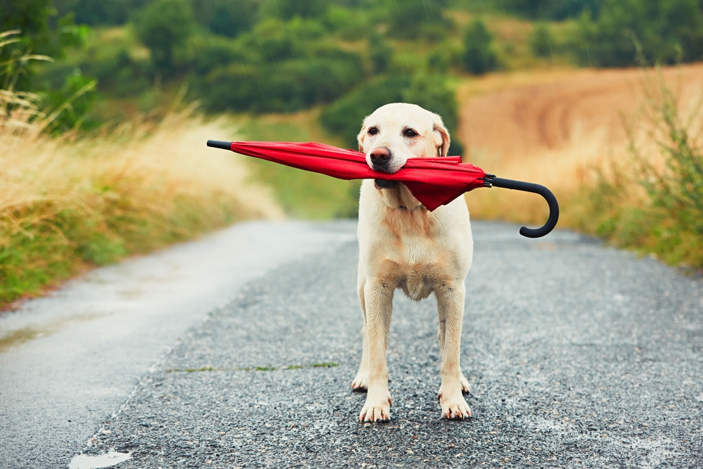

1. Fetching With Them

Instead of just sitting on the couch while your dog does all the work playing this popular game, use a hallway in your home to trade positions with them when you throw. Another alternative is changing locations, moving the game from room to room and the same goes playing for tug-of-war. Don’t let your dog do all the work, join them in these activities.

2. Hide-And-Go-Seek

Rather than just playing fetch with your dog, make them work to find their favorite toy by hiding it in different locations throughout your house. Tell them to sit and stay while you leave the room to find a hiding spot for their plaything. You may have to help them out the first few times if they’ve never played before this game before, but soon they’ll truly enjoy this seeking activity.

3. Stair Stepping

If you happen to have a two-story home, take advantage of these steps with some healthy exercise routines. If you’re throwing their favorite toy to the top of the stairs, follow along so you can stay trim at the same time. Try playing tug of war while you’re climbing the stairs from a seated position, this is actually a great workout for everyone’s legs.

4. Create An Obstacle Course

Similar to their first time playing hide-and-go-seek, they won’t know what to do once you’re set up an obstacle course for them so you’ll have to guide them through the route. There’s plenty of things laying around the house that you can use as obstacles, like:

- Empty or full cans to traverse around
- An empty box with both ends open to travel through
- Chairs or stools to jump over or go through
- Teach them to stand or balance on a milk crate or stool
- Get them to jump through a hula hoop

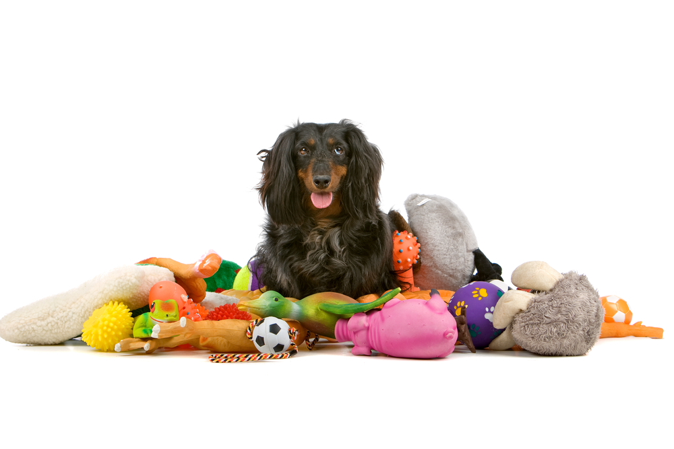
5. Clean Up Time

This is a great way to teach your dog a useful skill that will require activity for both of you, training them to pick up after themselves. If your dog has a number of playthings, they probably already have a box for their toys, but you can always use something like an empty laundry basket or other container. Scatter the toys all around a room and let the training begin.

First you’ll have to teach them what “put it away” actually means by showing them what to do while repeating the command. Once they’ve conquered the concept, increase the level of difficulty by moving the toys to other areas and rooms throughout your house. Once again, you’ll have to go with them to these other rooms at first, but they’ll pick up the routine after a while.

Be sure to give them plenty of encouragement, love, affection and perhaps a few treats to enhance their playtime. A rainy day indoors doesn’t mean we can’t still have some fun with our precious pets.

